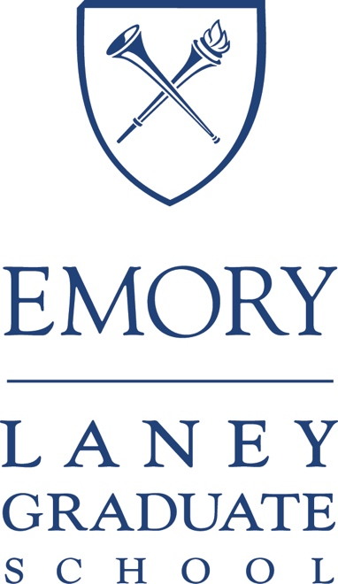

Professional Development Support Funds Handbook AY2026-2027

Welcome to the Professional Development Support Funds Handbook. This Handbook exists to help Laney Graduate School PhD students navigate the PDS application processes for conference, research, and training PDS funding requests. If you are intending to apply for PDS funding, please make sure to always consult the current version of the PDS Handbook (always use the website version, do not download an older version).

PDS applications are important in doctoral education for several reasons:
- They aim to help students prepare to apply for funding from external agencies. In other words, this is to help students practice writing a funding application for other external funding agencies.
- They aim to help students (a) acquire training pertinent to their degree not offered at Emory University, (b) conduct research for their dissertations and research projects, and (c) network and present at conferences.

If you have any further questions after reviewing this Handbook, please contact us at: LGS.profdev@emory.edu.
Table of Contents
(Please click to navigate)
Version History 2
Preliminary Information 3
Travel Information 6
Professional Development Supports Funds 2026-27 Calendar 7
How to Prepare Before Application Submission 8
What To Do After Application Submission 9
How to Submit the PDS Report 10
PDS Expense and Budget Guidelines 12
PDS Funding: Conference 18
PDS Funding: Training 20
PDS Funding: Research 24
How to Submit a PDS Application (LaneyConnect) 28
How to Return Remaining PDS Funds 35
Frequently Asked Questions (FAQ) 36
Tax Matters 45

Version History
Current version of the PDS Handbook is v1.1
V1.1
- Added clear information about what the faculty advisor will submit for their student’s competitive applications (under the competitive subsections in PDS Funding: Training and PDS Funding: Research).

V1.0
Changes from last year’s PDS Handbook
- Updated deadlines and notification dates in the PDS Calendar.
- Added a new section, How to Submit the PDS Report, to help students quickly find this information.
  - This information was embedded within a larger section in the previous PDS Handbook.
  - We have also clarified language in this section to help students understand what is required for the approved application to be marked as “Complete” (in LaneyConnect) after they have returned from their conference, training, or research activity.
- Updated guidelines in How to Return Remaining Funds since the LGS Suite has moved to a new location for the current academic year.
- Clarified eligible and ineligible costs in the PDS Expense and Budget Guidelines section.
  - Expanded language about what could constitute “Cloud computing” which was an eligible expense previously: it now explicitly states Cloud GPU and OpenAI API are eligible under this category.
  - Related to transcription: interpretation services are also eligible if the language is not a language the student would have to know for their own PhD program.
  - Cell phone roaming costs remain ineligible, and it now explicitly states that SIM cards are also ineligible.
  - Software costs remain ineligible, and it now explicitly states that other software subscriptions such as AI tools (e.g., ChatGPT, Anthropic, etc.) are also ineligible.
- Updated information in Tax Matters section for FY2026.
- Updated information for mileage costs for FY2026 (the PDS Handbook will be updated with FY2027 mileage once the IRS provides this information in 2027).

Preliminary Information
For this academic year, the PDS application is projected to start receiving applications starting September 1. Before this date, you may not be able to submit any applications.

LaneyConnect
Students will apply for PDS funds through LaneyConnect and submit their PDS Report through this system.

General Funding and Disbursement
All funds are disbursed directly to the student. PDS will not pay labs, the student’s PI, or any other advisor. The student’s graduate program administrator or designated staff member can assist the student in releasing the funds to the student once they have been approved for funding. After the application has been approved, please check with the graduate program administrator (PA), or another designated staff member responsible for processing PDS funds, regarding the disbursement of funds. LGS Finance will not provide Speedtypes, and purchases should be made using the student’s own personal payment method, including (when applicable) airfare through Emory Travel (travel.emory.edu).
Laney Graduate School PhD students are eligible for PDS funds provided for by generous donations to LGS, but the funds should not be viewed as guaranteed regardless of the circumstances. No PDS fund belongs to any individual student’s account or exists as a balance for any specific student. Each applicant is eligible to be approved up to the various limits for the PDS funding categories listed. Funds will be disbursed on a quarterly award model to ensure that funds are allocated and available throughout the entire year. If requests are greater than the amount available in each quarter, requests may be awarded, partially awarded, or declined based on a priority model.
For most programs, the priority they have elected for is by seniority (5+, 4, 3, 2, 1), though some programs have elected to use a different yearly priority. We cannot guarantee all funding approvals, but we estimate that students in the top two priority years are more likely to receive 100% of their requests, the third priority year may receive a partial request, and the fourth and fifth priority years may receive partial funding or be declined.

PA or relevant staff: If you have questions about the documentation needed or the Finance disbursement process, please contact Eric Trevena: eric.trevena@emory.edu.

Application Priority
Applications will be funded according to priority and allocated budget for each PDS cycle. The priority list for each program is displayed in the section below. The programs have elected for their respective prioritization: if you have questions about your program’s list, please contact your DGS.
Please consult the priority list for your program (or default list) below before deciding to apply or incurring any expenses in advance.

The priority list by program is as follows:
The default prioritization (from highest to lowest) is in order of seniority for all application types: 5+, 4, 3, 2, 1.
The following programs have elected to use alternate prioritization:
- CSI: 2, 1, 3, 4,5 (Research/Training)
- Economics: 3, 4, 5+, 2, 1 (Conference); 2, 3, 4, 5+, 1 (Research/Training)
- English: 2, 3, 4, 5+, 1 (Conference); 4, 3, 1, 5+, 2 (Research/Training)
- Epidemiology: 4, 3, 2, 1, 5+ (All applications)
- History: 1, 2, 3, 4, 5+ (Research/Training)
- MSP (GDBBS): 3, 4, 5+, 2, 1 (All applications)
- Religion: 3, 4, 5+, 2, 1 (All applications)
- WGSS: 2, 3, 4, 5+, 1 (Conference); 4, 3, 1, 5+, 2 (Research/Training)
We highly recommend that students in the lowest priority year(s) reconsider before submitting their applications or incurring any expenses in advance.
While we cannot predict how much funding students will request during each quarter, it is possible that students in the lowest two priority years will receive partial or no funding. If you have questions about the prioritization for your program, please speak with your DGS.

Application Timeline/Eligibility
Students may either (1) apply before the start of the event or (2) apply after the event has concluded during the posted cycles. Funds are not guaranteed in all circumstances, however, so please do not incur any costs unless you are able to cover the full cost of the conference/training/research activity in cases where you may receive no funding or partial funding. If you are applying for an event that has already concluded, it must have taken place on or after 8/1/2026 and subject to normal PDS deadlines for the year. If the conference, research, or training activity is slated to begin after your projected graduation date, it is not eligible for PDS funding.

Total Funding Eligibility
Applicants are eligible to be approved for the following (see the FAQ section for details about these totals):
- Three categories of their own lifetime eligibilities: up to $2,500 conference funding; up to $2,500 non-competitive training funding; up to $2,500 non-competitive research funding. Successful competitive training or research applications automatically subsume all remaining non-competitive lifetime eligibility for the training or research category. There is no competitive conference funding.
- Up to $5,000 total eligibility for non-competitive and competitive training/research funding. Beyond this point, the student must always apply for competitive training/research funding.
- Up to $8,000 lifetime research and training funding in any combination of competitive and non-competitive funds.

Taxes
Please make sure to refer to the Tax Matters section at the end of the PDS Handbook.
Students who were approved for funding in FY26, and who have any received funds remaining that they need to return must ensure that the funds are received and processed into Emory University’s bank account by November 15, 2026 in order for the Tax Office to have time to update the tax record for FY26.

Non-Resident students
PDS funding may be subject to tax withholdings, depending on the nature of their home country's tax treaty for all PDS Conference, Training, and Research funds. These are withholdings that follow international tax laws and therefore PDS has no control over this process. PDS will not cover any taxes withheld for PDS funds and therefore students may not calculate additional taxes for their applications. If you have questions about the tax implications, you should contact Emory’s tax office.
If you are a non-resident student, please ensure that your PA includes the following documents in their request for fund disbursement in the Finance system if you are approved for PDS funds (this is required EACH time):
- Copy of passport picture
- Copy of visa picture page
- Copy of I-20 for F-1 // Copy of DS-2019 if J-1
- Copy of I-94 record (student can obtain from https://i94.cbp.dhs.gov/home)
- Emory Compliance Statement for Payments (see https://finance.emory.edu/home/financedivision/accounting/forms/index.html)
- W-8BEN (completed and signed – signature must be pen to paper signature)

Resident AND Non-Resident students
The tax treatment of scholarships, subsidies, fellowships, grants, awards, or stipends may vary for each student. Student should consult the IRS for information about taxes. Emory University does not offer personal tax advice. Instead, Emory University recommends seeking professional tax counsel whenever necessary.

Students may not gross up their funding request to make up for any associated withholdings or taxes.

If you have submitted the required evidence of your conference presentation in your PDS application and you are subsequently approved for conference PDS funding: please make sure your PA receives a copy of these documents separately (they must attach such documents in the fund disbursement request).

Travel Information
International Travel
All students who participate in international travel for training and research must register with ISOS. If you find yourself in an emergency, which includes being a victim of a crime, you should immediately contact ISOS for assistance. Please note, however, that ISOS is not travel insurance and neither ISOS nor PDS will reimburse you for personal property that is affected by any travel conditions or incidents.

IMPORTANT: Students traveling abroad (i.e., traveling out of USA) must have the International Travel Clearance Form (ITC) submitted and approved prior to approval of PDS funds. This is not ISOS registration and is completely separate from the PDS application process: please visit the PDS homepage for details.
For questions about the ITC Form, please contact LGS Student Affairs: lgs.studentaffairs@emory.edu.

Flights funded by PDS
Airfare must be purchased through Emory Travel: CTM or Sequel/Deem if requesting PDS funds for flights. They must be purchased using the student’s own personal payment method. Flights purchased outside of Emory Travel or Sequel are not eligible for PDS funding. Buses or trains do not need to be purchased through Emory Travel.

Information Regarding CTM:
For travelers who have booked travel via Emory Travel (CTM), please review and update their profile first before booking any reservations.
For travelers who have never booked travel through Emory Travel (CTM) or have not booked since the start of the COVID-19 pandemic, the person must contact travel@emory.edu prior to gaining access to their travel profile on CTM. Each traveler is verified through the Emory system and once verified, Emory Travel will work to activate/re-activate the profile and the student will receive instructions on how to log-in to their profile on CTM.
If you have never booked travel through CTM or have not booked since the start of the COVID-19 pandemic, do not attempt to log-in until you receive confirmation from Emory Travel.
If the student is somehow unable to access CTM, they may use Sequel/Deem
Emory Travel website: https://www.finance.emory.edu/home/procurement/travel/index.html
- In some cases, it may be desirable to purchase flights prior to approval for PDS funding. PDS will accept pre-purchased flights (only through Emory Travel) as the flight expense documentation, with the implicit acknowledgment from the student that they have not yet been approved for any funds. This policy also extends to other time-sensitive costs, such as lodging that must sometimes be booked, and paid for, in advance. Do not purchase the flight in advance or incur other costs if you are unable to cover the full cost in cases where you do not receive any PDS funding.
- Since flight prices fluctuate regularly, it is the applicant’s responsibility to apply in a timely manner and purchase flights according to the originally stated budget (in advance, if necessary). Once a student has been approved for funding, there may be no updates made to the original budget.

Mileage vs. Flights
If a student elects to drive (longer than 4 hours one-way driving) instead of flying, they must include the following information with their mileage documentation:
- Normal mileage documentation
- What the flight would cost for the same days of travel
PDS will fund whichever is the lesser amount of the two costs. For example:
- If electing to drive from Emory University to Vanderbilt University (~500 miles round trip):
  - Mileage would cost: 500 miles * $0.725/mile (FY26) = $362.50
  - Flight averages: $150-250
The student may request up to the current flight estimate if electing to drive and submitting mileage costs.

Flight Documentation PDF
If you are submitting a dummy booking or a flight receipt from Emory Travel as part of your flight documentation, it must show the following: (1) departure/arrival airports and (2) the exact dates of travel.

Professional Development Supports Funds 2026-27 Calendar

Please coordinate any external deadlines with the PDS deadlines and pay close attention to the deadline dates and notification dates when preparing your application. Students are not required to already be accepted into conferences, training activities, or research archives before applying, so students should apply as early as possible. Applicants may always decline the PDS funds after they are approved.
Applicants may expect to receive an email notification on the notification dates listed below. They will generally not receive any notifications before the posted dates.

PLEASE NOTE: If you do not receive an approval/decline email by the notification date, the most likely reason is that the application is incomplete. You must contact our office at LGS.profdev@emory.edu within two weeks of the notification date. If we do not receive any communication from the applicant, the application will be declined. This does not apply for competitive applications; incomplete applications for competitive cycles will automatically be removed from consideration.

Type of Application | Application Deadlines | Notification Dates
Conference | September 15 | October 16
Conference | December 15¹ | January 29
Conference | March 15 | April 16
Conference | June 15^{2, 3} | July 16

Training and Research  Non-competitive | October 15 | November 20
Training and Research  Non-competitive | January 15¹ | February 26
Training and Research  Non-competitive | March 16 | April 24
Training and Research  Non-competitive | May 15^{2, 3} | June 25

Training and Research  Competitive | October 5 | November 13
Training and Research  Competitive | February 8¹ | March 12

¹ Students graduating in Fall 2026 are not eligible to apply during this cycle and any cycles thereafter.
² Students graduating in Spring 2027 are not eligible to apply during this cycle and any cycles thereafter.
³ Students graduating in Summer 2027 are not eligible to apply during this cycle.

PLEASE NOTE: Any conference, training, or research activity that is scheduled to begin after the student’s projected graduation date is not eligible for PDS funding. They may not apply in advance if the event takes place after the graduation date.

For example, if the student is graduating in May 2027, they may not apply to receive funding for a conference that is scheduled to take place in July 2027 at any point in the year.

How to Prepare Before Application Submission
- Submit PDS Report(s) for All Previously Approved PDS Applications
See the What To Do After Application Submission section for details.
  - Use the LaneyConnect system to submit the PDS Report to your program administrator. You do not need to download any forms from the PDS webpage; everything will be submitted through the online portal. When you submit the PDS Report online, it will generate an email to your program administrator (or staff person responsible in your program for PDS apps.) and they will click the link therein to review the information about your application and certify that what you have entered is accurate. Please note that it generally takes between 1-3 hours for the system to generate an email to your PA.
  - The current application cannot be approved until all previously approved applications have their PDS Reports completed. The only exception to this case is if the previous PDS funded activity (conference, training, or research) has not yet concluded.
  - [If returning any funds]: DO NOT submit the PDS Report until after you have confirmed with your program administrator that you have returned any remaining funds along with the required PDS Return Form back to LGS Finance (see How to Return Remaining PDS Funds).

- Download the Correct Advisor Signature Form
There two types of signature forms available online, one for Conference applications and one for Research or Training applications (either non-competitive or competitive applications; they all use the same form).
Visit: https://www.gs.emory.edu/professional-development/pds/apply.html (under the sidebar PDS Forms).
Do not use older versions that you may have found online or downloaded from past academic years.

- Prepare Documentation of All Expenses
For best practices in submitting a correct application, please visit the section, How to Submit a PDS Application (LaneyConnect). Each budget item you enter must have documentation that shows why it costs the amount you entered (in $USD not foreign currency).

- Prepare Table Summary of All Expenses (in USD): This must be included in your application.

Prepare your PDS application by obtaining the documents listed below, depending on the type of application (all in correct orientation):

Conference:
- A completed and signed PDS Conference Participation – Advisor Signature Form (2026-27)
- A PDF cover page or email from the conference organizer that must include the following information: (1) conference title; (2) conference dates; and (3) conference location. DO NOT upload the entire booklet.
- Documentation for each expense in $USD (consult the PDS Expense and Budget Guidelines section for details).
- A table summary of all expenses as line items listed in USD. We have provided an example in the section, How to Submit a PDS Application (LaneyConnect) below.

Research or Training (non-competitive or competitive):
- A completed and signed PDS Research or Training – Advisor Signature Form (2026-27)
- Documentation for each expense in $USD (consult the PDS Expense and Budget Guidelines section for details)
- A table summary of all expenses as line items listed in USD.
- [Competitive applications]: Current CV
- Make sure your faculty support documentation is submitted by your faculty member by the deadline. T

Please note: A partially completed application form cannot be saved. Be sure you have all the items you need to complete the application. Applications with missing documentation may have that portion removed from consideration for funding. In such a case, they must wait until the next PDS cycle to apply for any remaining expenses (if eligible).

What To Do After Application Submission
After the student has submitted their application, they should receive an email confirmation that they have submitted the PDS application. By the notification date listed, the student and the program staff person responsible for processing PDS funds should receive an email regarding the final approval or disapproval of the application.

If the student receives an approval email notification, there are two options:
Option #1: Student accepts the approved funding:
- Contact your graduate program administrator or designated staff person responsible for processing PDS funds in your PhD program, and request that your approved PDS funds be disbursed to you. They will provide any specific instructions to process the PDS funds and may provide you with a general timeline on when you may expect to receive the funds.
If you are a non-resident student, please see the Preliminary Information section above on all required forms.
- Use the funds according to the original budget and complete the conference, training, or research activity.
- Submit PDS Report through LaneyConnect after you have received the funds and completed the activity.
  - [If returning remaining funds]: DO NOT submit the PDS Report until after you have confirmed with your program administrator that you have returned any remaining funds along with the required PDS Return Form back to LGS Finance (see How to Return Remaining PDS Funds).*
- Confirm with your program admin that they have received the email regarding your PDS Report and that they have updated your application record.
- Our office will review the student/PA’s final PDS Report and generate a final email to both the student and the PA to indicate that this application is now closed.

Option #2: Student declines the approved funding:
It is possible that the student’s plans have changed and so they longer wish to utilize the funds they have been approved for. To maintain an accurate record of all approved applications, please proceed as follows:
- Submit the PDS Report through LaneyConnect where the student will decline the funds.
  - [If returning received funds]: DO NOT submit the PDS Report until after you have confirmed with your program administrator that you have returned any remaining funds along with the required PDS Return Form back to LGS Finance (see see How to Return Remaining PDS Funds).*
- Confirm with your program admin that they have received the email regarding your PDS Report and that they have updated your application record.
- Our office will review the student/PA’s final PDS Report and generate a final email to both the student and the PA to indicate that this application is now closed.

*The approved applicant may have received funds that they need to return (whether in part or in entirety). In such cases, please visit the appropriate section linked above.

If the student receives a disapproval email notification
The student should read the comments section within the notification that will indicate the reason for disapproval. The student should consult the FAQ section of this Handbook to see if they are eligible to resubmit for the next PDS cycle. The student does not need to submit a PDS Report for this application. The disapproval effectively closes this application.

How to Submit the PDS Report
Please see the screenshots and information below on how to correctly submit the PDS Report on LaneyConnect after your conference, training, or research has concluded (and have received the funds) or after you have decided to decline the approved funding.

Please note: Students with outstanding PDS Reports may not be eligible for future PDS funding until PDS Report(s) for previously approved applications have been completed by the student and certified by their graduate program administrator. The only exception to this case is if the prior activity (conference, training, or research) has not yet concluded. Applications must have status “Complete” (see below) for the application to be considered closed.

Visit LaneyConnect where you originally submitted your PDS application and click the PDS Funds tab:
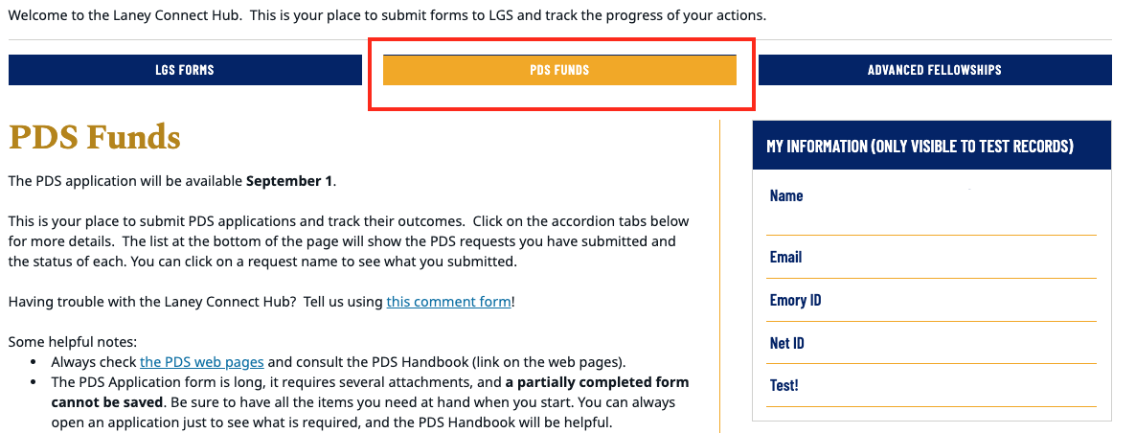

Then scroll down to where your submitted applications are displayed:
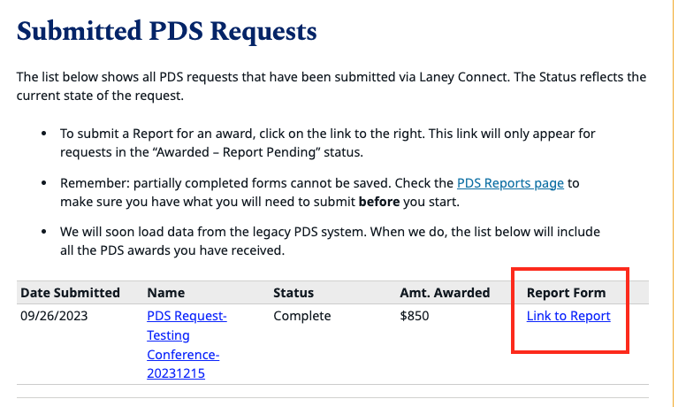
Click “Link to Report” which will take you to an online form where you will enter:
- Whether you accept or decline the funds
- The amount spent (if you spent more than what you were approved for, only enter the total approved amount since anything beyond what was funded by PDS is not relevant)
- The date you received the funds
- Information about LGSC travel grants you may/may not have received
- Table summary of expenses (this should match up closely with the original table submitted)
- Your certification that the information is accurate

If you are returning funds, please do not submit the PDS Report until after you have returned the funds with the completed PDS Return Form back to Emory University. Then provide confirmation to your graduate program administrator (or designated staff person who reviews the PDS Reports) that you have done so.

Steps needed for the application to be “Complete”:
- The student completes their PDS Report.
- The PDS Report is routed to their PA to certify the information student has entered.
  - It is the responsibility of the student to make sure their PA does their part here.
- The PDS Report enters into a final review queue to ensure all information is correct. Once confirmed, both the student and the PA will receive a final email to that effect and the application will be marked “Complete” in LaneyConnect.

All three steps above must be completed.

If any applications show “Awarded –Report Pending” or “Awarded – Report Submitted” (this means the student’s PA did not yet review/certify the student’s Report) then that means the student may not be eligible for PDS funds in the future.
- The exception to this policy is if the activity (conference, training, or research) has not yet been completed and the student may wait until the activity has concluded to submit the PDS Report and can still submit a new application.
Older legacy PDS applications will display “NA” instead of a link to the Report and no further action items are needed for such applications.

When needed: On LaneyConnect, the student should be able to click the appropriate hyperlink(s) to access their previously submitted PDS Report(s).

PDS Expense and Budget Guidelines
This section explains what kinds of expenses may be eligible or ineligible for PDS support and what kinds of supporting documents should be uploaded in the online PDS application. This is not an exhaustive list but serves as general guidelines. LGS will ultimately determine eligibility for funding. If you are considering including an item in your budget which is not covered in the table below, please contact LGS.profdev@emory.edu. We will consider the issue and provide guidance. We strongly encourage all students to submit any relevant questions before applying. Resolving any questions may take some time, so please start preparing your application as early as possible before the deadlines.
PLEASE NOTE: Funding is not guaranteed. Do not incur any expenses in advance if you are unable to cover the full cost of the conference, training, or research activity in cases where you do not receive any PDS funding (or only receive partial funding).

Food Expenses
PDS will generally follow the University guidelines with respect to how much students may budget:
- For destinations within the lower 48 Continental United States: refer to the General Services Administration per diem rates https://www.gsa.gov/travel/plan-book/per-diem-rates. (For AK and HI, please use the link above to search Alaska/Hawaii first, then it will provide information on where to obtain per diem rates for those states).
- For foreign rates, the U.S State Department establishes per diem rates in USD: https://aoprals.state.gov/web920/per_diem.asp. Find the country and city to identify the M&IE Rate.
- M Total is the maximum allowed (do not include incidentals).

Other Information
- If you receive a Laney Graduate School stipend (not PI or grant funding) during the time you will engage in the training or research, then it is expected that the stipend be used towards part of the lodging expense, whether you are staying in the Atlanta area or traveling to another location ($25/night). If that applies to you, please refer to the FAQ under the specific question, [For training and research PDS applications]: What is the section “Amount of Stipend Applied” that is found in the application portal?
- Please remember to provide justification for all projected costs—explain why the training or research requires the listed expenses. The justifications need not be lengthy, but they are required, and they should show evidence that the projected costs are based on real needs with reasonable costs.
- Airfare funded by PDS should always be purchased through Emory Travel (travel.emory.edu).
- While we highly recommend students wait until approval before purchasing flights, we acknowledge that in some circumstances, it may be in the best interests of the student to purchase flights in advance. Airfare must be purchased through Emory Travel CTM or Sequel/Deem if requesting PDS funds for flights.
- Therefore, pre-purchased flights (through Emory Travel only) may be submitted and remain eligible for PDS funding, with the implicit acknowledgment from the applicant that they have not yet been approved for any PDS funding.
- For training/research: if the student is accessing archives or another institution’s resources or collaborating on research at another location, there should be official documentation from that location included in the student’s PDS application (they should amend it to one of the PDF file uploads).

Expenses without any supporting documentation may be removed from consideration for PDS funding.
- All expenses should have clear supporting documentation or table summary attached to show the expenses.
- All expenses must be converted to USD on the PDFs uploaded (insert a small table or a second page that shows the conversion rate to USD).
  - Foreign expenses that do not show clear conversion rates in the table may be removed from consideration for PDS funding.
- If there are several fee schedules for any costs listed on your PDF file, please circle/box the exact cost that is relevant for your application within the PDF.

Item | Eligible | Supporting Documents to Submit When Applying | Not Eligible
Conference Participation Support
Travel | - The cost of travelling from Atlanta to the location of the conference, by plane (coach fare), train or bus. Other departure locations will be considered with justification. See FAQ.  - Mileage costs for driving to a conference that is not in Atlanta, at the current university rate (See Emory Travel). | - Print-out or screenshot of relevant reservation or other price quotes for flights.  - A Google or other map that indicates the distance to be driven.  For mileage costs, provide a table of total miles driven, with the current IRS rate calculated (FY26 = $0.725/mile). | - Pre purchased gas with car rental.  If seeking mileage costs, gas costs may not be included.  - Travel to conference in the metro-Atlanta area (including parking costs).  - Any extra days (beyond 1 day) before or after the conference dates. See the FAQ for some flexibility on this point.
Lodging | - Hotel costs, AirBnB, or other lodging costs. | - Print-out of hotel reservation or other relevant price quotes. | - Non-budget hotel/lodging. E.g., students should not request PDS funding for a premium suite in a luxury hotel.  - Any extra days (beyond 1 day) before or after the conference dates.  - Lodging for conferences in the Atlanta area.
Registration Fees | - The fee for registering as a participant or attendee in a conference. | - Conference announcement with registration cost.  For pages with various fees, please circle/box your fee. | - Membership fee in the conference organization.
Other Expenses | - This money is intended to support the cost of meals, local transportation (bus, subway, airport shuttle), and other incidentals (tips, service charges, etc.).  - Rental cars (economy)  If submitting any expenses in this category, the student must submit at least a table or estimate of these expenses. A request for Other Expenses with no documentation or clear explanation may be removed for consideration for PDS funding. | - Estimates of specific daily expenses, using screenshots from Uber, other transportation websites, and/or per diem budget at reasonable rate.  - Receipts may need to be submitted to the student’s own PhD program administrators after student’s return from their conference. Consult with your own program regarding their policy around receipts.  We recommend students keep an accurate record of all receipts. | - Any extra days (beyond 1 day) before or after the dates of the conference.  - Poster printing  - Abstract fees  - Other excursions  - Passport or Visa costs
Training and Research Support
Travel | - The cost of travelling from Atlanta to the location of the conference, by plane (coach fare), train or bus. Other departure locations will be considered with justification. See FAQ.  - Mileage costs for driving to a training or research location that is not in Atlanta, at the current university rate. | - Print-out or screenshot of relevant reservation or other price quotes for flights.  - A Google or other map that indicates the distance to be driven.  For mileage costs, provide a table of total miles driven, with the current IRS rate calculated (FY26 = $0.725/mile). | - The cost of travelling within the Atlanta area.  - Pre purchased gas with car rental.  If seeking mileage costs, gas costs may not be included.  - Any extra days (beyond 1 day) before or after the training or research dates. See the FAQ for some flexibility on this point.  - Job interviews.
Tuition and Other Fees | - Tuition or registration fees for courses, workshops or other training occasions.  - Fees for the use of research facilities such as laboratories, archives, etc.  - Fees charged by tutors or other instructors. | - Tuition and fee schedules.  - If a course offers scholarships to some students and you are eligible, please submit some evidence that you have applied for external funding (a copy of an application cover sheet, e.g.). | - Textbooks, journal articles, books, other literature.  - Other materials needed for courses, workshops, or other training occasions.  - Taxes associated with international treaties.  - Trainings that are unrelated to student’s progress to degree.  - Training that are connected to an academic conference.  - Workshops/trainings that are basically conferences and presentations of works-in-progress.  - Internet costs or cell phone roaming costs (this includes SIM cards)  - Passport or Visa costs  For applications involving language training: PDS will not fund language training under the PDS “Research” category. The student must apply under the “Training” category.
Research Equipment | - In general, PDS funds will not support the purchase of equipment.  - Specialized items (particularly those that are consumed by the research such as reagents or forms) required for research and not generally useful outside the research activity may be eligible.  - If funds for such items are approved, they will be the property of Emory Graduate School and should be returned at the end of the research. | - Documentation of the features and price of the item.  - Justification for why this item is necessary for the research.  - If the research is conducted at Emory, the applicant must provide evidence that the item is not available at Emory or is not available to the student. | - Items that need to be used in the research, but which are also generally useful outside the research activity.  - Examples include laptop or other portable computers, tablets, cameras, software, common lab equipment, etc.  - Office supplies (pens, notebooks, etc.).  - Internet costs or cell phone roaming costs (this includes SIM cards)  - AI tool subscriptions (such as ChatGPT, Anthropic, etc.)
Other Research Costs | - Transcription  - Participant incentives  - Duplication of forms  - Reproduction of archive materials, up to $200  - Cloud computing (e.g., Cloud GPU and OpenAI API usage)  - Interpretation services (if the language is not a language the student would have to know for the program) | - Documentation of the transcription rate. Transcription rates between $1.00 -$1.25/audio minute are typically approved under PDS. Students are required to complete 25% - 50% of their own transcriptions.  - Documentation showing that incentives are at a customary level.  - Documentation of duplication costs. | - Duplication of research articles or other background materials  - PDS will not fund open-access expenses or other expenses related to publications.  - Teacher training  - Workshops/trainings that are basically conferences and presentations of works-in-progress.  - Paying for (research) assistants  - Passport or Visa costs
Lodging | - If you receive a Graduate School stipend during the time for which you seek PDS funding, it should be used to cover living expenses at the rate of $25/night.  - If a course, workshop, laboratory etc. offers housing at a special rate (in dormitories or other places), you are expected to use that housing.  - If possible, we expect you to share a room.  - For short-term stays, hotel costs at budget hotels.  - For longer term stays, reasonable rental costs for student rooms or similar accommodations. | - Cost schedules from the location of training or research.  - Hotel cost schedules, including some comparisons of suitable options. | - Housing in the Atlanta area or in your primary residence.  - Non-budget/regular hotel rooms (e.g., a high-cost suite would not be eligible for PDS funding).  - Costs of an apartment here in Atlanta that you choose to retain while you are away conducting research or engaging in training.
Daily Expenses | - Domestic or outside the U.S., an estimated amount for daily expenses using information about meal costs. | - Screenshot or printout of daily expenses  If submitting any expenses in this category, the student must submit at least a table or estimate of these expenses. A request for Daily Expenses with no documentation or explanation may be removed for consideration for PDS funding. | - Living/lodging costs in the Atlanta area.  - Living/lodging costs for long-term stays based on restaurant costs.  - Cell phone costs (for roaming; including SIM cards)
Local Transportation | - In general, the daily expenses allocation is expected to cover local transportation (bus, subway, etc.).  - If local transportation requires other means – purchasing a bicycle, traveling by taxi, renting a car, or other arrangements – then these are eligible expenses.  - Travel in the extended area of the training or research location – train travel and similar things. | - If local transportation requires special arrangements, explain and document why those arrangements are necessary. Plausible justifications include personal safety.  - If you need to travel in the extended area of the training or research, explain why such travel is necessary.  - Locate information that helps you develop a reasonable estimate for the location in question and provide that estimate and an explanation. | - Local transportation in the Atlanta area.  - When mass transit is available, the presumption is that it will be used, and other arrangements need to be justified.  - Local transportation unrelated to the research or training (e.g., tourism or visiting).

PDS Funding: Conference
Conference participation support is subject to lifetime eligibility. Students are advised to keep the lifetime eligibility and program prioritization model in mind when making decisions about applying for conference funding. There is no competitive conference funding. All applications for conference support will be reviewed by the Laney Graduate School to ensure that the student is eligible and that the budget is within guidelines.

A. Eligibility Requirements
- The applicant must be enrolled in an eligible Emory doctoral program at the time of the activity.
- The applicant must be in good standing at the time of the application, in the LGS as well as in their programs.
- The applicant may not have more than one incomplete at the time of application.
- The applicant must have submitted PDS Reports for all previous activities funded by PDS. This includes submitting a PDS Report to decline funding for previously approved applications. The exception to this policy is if the activity (conference, training, or research) has not yet been completed and the student may wait until the activity has concluded to submit the PDS Report and can still submit a new application.
- The applicant must meet any program requirements, when applicable.

B. Support
Any type of conference participation is eligible for funding, including presentation of papers or posters, commenting, panel discussions, and simply attending. The student’s advisor should help determine whether a conference has scholarly merit, and whether the student’s participation in this conference is appropriate. Support is limited to travel to the conference site, conference registration, lodging costs, and other relevant expenses. More information is available on the PDS Expense and Budget Guidelines section of this Handbook. Virtual conferences are also eligible for funding. Please note: Poster printing costs, abstract fees, and excursions are not eligible for PDS conference funding.

C. Review/Timeline
There are four PDS Conference cycles. Students will receive an approval or disapproval notice on the notification date listed for a given PDS cycle.

D. Funding Eligibility
For conferences the applicant has a lifetime eligibility of up to $2,500. Once the student has exhausted the lifetime eligibility for conference funding, PDS will not fund any future conference activity. There are no candidacy limits for PDS conference applications. There are no competitive PDS conference funds.

E. Application Materials
- Signed and completed PDS Conference Participation – Advisor Signature Form (do not use a previous year’s version but download the current version from the PDS webpage).
- Documentation of the conference, regardless of whether you are presenting at the conference or not. Do not submit the whole conference program, but a one-page PDF or screenshot from the conference organizer that must include (1) the conference title, (2) dates, (3) location, and (4) if applicable, your involvement in it.
- Documentation for all budget items, which in most cases, is printed from the web. This includes documentation for any line item you fill out on the application, i.e., mileage for driving, plane fare, conference fees (excluding membership dues), lodging costs, or other expenses. For more information, please see the PDS Expense and Budget Guidelines or FAQ sections of this Handbook for how to enter this information correctly.
  - Failure to include documentation for any extra budget items will result in these expenses being removed from consideration for PDS funding. Convert all foreign costs to USD by inserting either a textbox or a table to display the conversion.
  - If you upload a registration page with several fee schedules, please highlight/box the exact expense you are referring to.
- Table summary of all expenses in USD.
- Any other internal program requirements must be met. These are dependent on your program. Check with your PDS contact in your PhD program for any clarification.

F. Pre-Planning
- Ensure that you have submitted completed PDS Report(s) for all previously approved applications.
- It is best practice to apply as soon as you know you will be attending the conference. Conference organizations plan for their conferences many years in advance, so you should have the information necessary to apply ahead of time.
- Do not incur any expenses in advance if you are unable to cover the full cost of the conference activity since in some cases, students will receive partial funding or no funding.
- Consult the section, How to Prepare Before Application Submission.

G. Application Submission
Please visit the section in this Handbook, How to Submit a PDS Application (LaneyConnect).

H. After Submission
Please visit the section in this Handbook, What To Do After Application Submission.

Please note:
If at the time of PDS application submission, you selected NO and did not upload proof of your conference presentation (but plan to have an abstract accepted at the conference), please see the information below.

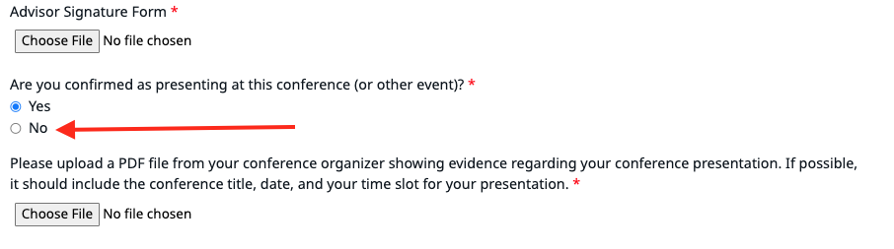
(Total funds received for the year is less than $2,000; see Tax Matters section): If you have already been approved for the PDS conference funding and now have proof of your conference presentation, please provide the following to LGS.profdev@emory.edu by December 15, 2026.
- PDF file of the PDS approval email.
- PDF file of your conference participation: it must clearly show the conference title, date/time, presentation title, and your name for a conference presentation slot.

Please ensure all items are legible and in correct orientation.

We will forward this information to the Tax Office, so that your PDS conference application approval remains in-line with what is indicated in the Tax Matters section of the PDS Handbook.

PDS Funding: Training
Funding for supplemental training is intended to support instruction that is essential for student’s research progress towards their degree and is not available at Emory. This progress does not entail teacher training or other professionalization trainings. There is no limit on the number of times a student apply for PDS training funds, but the eligibility is dependent on the total amount of previously approved funds (both in the non-competitive and competitive categories). Once the student’s cumulative approved PDS funds (i.e., prior training funds received plus the current request) for support exceed the non-competitive eligibility total of $2,500, the student must apply for competitive funding.
Competitive applications are judged by a multi-disciplinary faculty committee. Funding is based on the training’s contribution toward the student’s progress, the student’s use of previous PDS funding, as well as efforts to find external support for the current proposal. The competitive process is highly competitive and only a select number of applications will be funded. Due to the total budget available, not all applications will be funded, and in some cases, students may receive partial funding for their application.
Successful competitive applications automatically subsume the remaining non-competitive lifetime eligibility for the student in the training category. All applications for training support will be reviewed by the Laney Graduate School to be sure that the student is eligible and that the budget is not excessive.

A. Eligibility Requirements
- The applicant must be enrolled in an eligible Emory doctoral program at the time of the activity.
- The applicant must be in good standing at the time of the application, in the LGS as well as in their programs.
- The applicant may not have more than one incomplete at the time of application.
- The applicant must have submitted PDS Reports for all previous activities funded by PDS. This includes submitting a PDS Report to decline funding for previously approved applications. The exception to this policy is if the activity (conference, training, or research) has not yet been completed and the student may wait until the activity has concluded to submit the PDS Report and can still submit a new application.
- The applicant must meet any program requirements, when applicable.
- [Competitive applications]: The applicant for competitive PDS funding must also upload copies of PDS Reports for all previously funded training and research activity in their application. These PDS Reports will be considered by the review committee.

B. Support
PLEASE NOTE: An event is not eligible for PDS training or research funding just because it is called a “workshop,” “seminar,” or other similar terminology: if the session is focused on a narrow subject-matter, if it involves presentations of work-in-progress, if it operates like any general academic or professional conference, or if there are attached workshops to a host conference, such events are not eligible for funding under the training or research category. In such cases, the student may apply under the PDS conference category only.
- Specific forms of professional training not available at Emory. In general, an event is eligible for PDS training support when it
  - involves acquiring a skill or method – examples include language proficiency (if the language course is not offered at Emory), statistical methods, laboratory techniques, interview procedures, etc.; and,
  - is advertised as a training involving faculty, tuition, and/or a specific learning goal. (see above, presentations of works-in-progress by faculty are not eligible under this category).
- Eligible expenses include tuition and transportation. Where the training takes place away from Emory and the student is not receiving stipend support, lodging expenses for the duration of the training may be eligible for PDS funding. If a student receives a graduate school stipend during the period of training, support for lodging must be pro-rated by $25/night. More information is available in the PDS Expense and Budget Guidelines and FAQ sections regarding the “Amount of Stipend Applied” field that is displayed in the online application.
- Acquisition of language not taught at Emory, or language training in a depth or character not available at Emory, when such training is essential to the applicant’s dissertation research is eligible. This includes both tutoring and formal classes.
- Students are expected to make full use of resources available at Emory before submitting PDS applications. These resources include summer classes oriented towards reading comprehension as well as the Structured Independent Language Study (SILS) program available through the Emory College Language Center.
- PDS funds do not typically support language classes needed to pass program language requirements. Classes for these purposes are routinely available at Emory, so please consult the available resources beforehand.
- Students seeking advanced or accelerated experiences must demonstrate that they have taken full advantage of Emory resources. While accelerated learning is an acceptable justification for PDS support of language training, such programs do not replace Emory resources. For example, taking an accelerated French program during the summer does not supersede the available French classes at Emory in the fall and spring.
- Support is available for training that is essential to a student’s progress towards degree.
- If you have doubts about a particular event, please send an email to LGS.profdev@emory.edu with specific information about the event along with any website links, if available.

C. Review
There are four non-competitive Training/Research cycles and two competitive Training/Research cycles. Students will receive an approval or disapproval notice on the notification date listed for a given PDS cycle.
- Competitive review considers the amount of previous PDS research and training funding as well as the current progress of the student to PhD degree. The review committee expects that previous projects will put the student in a better position to complete the proposed project or training. In addition, the review committee expects the students to have made diligent and exhaustive efforts to find external funding sources. Only a select number of proposals are supported under the PDS competitive category.
- Successful proposals (these must address the prompts within the online Training/Research application form), both competitive and non-competitive, are clearly written for an interdisciplinary audience. Please explain the significance of your proposal without use of jargon or technicality. Make sure that your budget and project timeline are explicitly related; members of the committee should have no difficulty determining when different parts of the project will be carried out.
- Applications for funds intended to support significant components of dissertation research through this training, including preliminary research, are expected to document that the student has pursued, and is pursuing, external grant funding. This documentation will typically include cover letters or pages from grant applications that were awarded, denied, or are pending review. Favorable consideration will be given to student requests that demonstrate a persistent effort to identify and apply for external funding.

D. Funding Eligibility
For training the applicant has a lifetime eligibility of up to $2,500 (non-competitive), given certain conditions:
- There is no academic year limit according to (non)-candidacy. Students are eligible to apply for any amount during the PhD program.
- Once a student has received $2,500 in non-competitive funding, they must apply for competitive funding.
- For certain amounts, the student must apply for competitive funding, even if part of the request may utilize non-competitive funding. For example: if a student is eligible for $1,000 in non-competitive funds and the application is for $2,000, they must still apply for competitive funding because the application exceeds the $2,500 non-competitive eligibility.
- These non-competitive limits are set. There are no exceptions to these limits.
- There is a $5,000 total eligibility for non-competitive and competitive training/research funds. Any amount beyond this, the student must apply for competitive funding (even if the student has not received $2,500 total of non-competitive training funds to-date). Please see the FAQ section for details.

E. Application Materials
- A complete proposal submitted online regarding the training you intend to acquire. This includes a signed and completed PDS Research or Training – Advisor Signature Form (do not use a previous year's version but download the current version from the PDS webpage).
- Documentation for all budget items, which in most cases, is printed from the web. This includes documentation for any line item you fill out on the application as it pertains to your training request. For more information, please see PDS Expense and Budget Guidelines section in this Handbook.
  - Failure to include documentation for any extra budget items will result in these expenses being removed from consideration for PDS funding. Convert all foreign costs to USD by inserting either a textbox or a table to display the conversion.
- Table summary of all expenses in USD.
- Any other internal program requirements must be met. These are dependent on your program. Please check with your PDS contact in your program for any clarification.

F. Pre-Planning
- Ensure that you have submitted completed PDS Report(s) for all previously approved applications.
- It is best practice to apply as soon as you know you will be attending the conference. Conference organizations plan for their conferences many years in advance, so you should have the information necessary to apply ahead of time.
- Do not incur any expenses in advance if you are unable to cover the full cost of the conference activity since in some cases, students will receive partial funding or no funding.
- Please consult the section, How to Prepare Before Application Submission.

G. Application Submission
Please visit the section in this Handbook, How to Submit a PDS Application (LaneyConnect).

H. After Submission
Please visit the section in this Handbook, What To Do After Application Submission.

[IMPORTANT: For competitive training or research applications]:
Please upload the CV in the correct upload field. In the online application, you will be able to generate a link to your faculty member, who will need to fill out a brief form of support for your application (no letter of recommendation needed). This is due at the same time as your application for the given cycle. If an applicant does not have their faculty support submitted by the deadline, their application will not be eligible for review. The email link will be sent between 1-3 hours after your submission, so please plan accordingly and submit earlier than the final deadline.
Please note that there are two cycles for competitive applications, once in the fall semester, and once in the spring semester. If there are certain training or research activities that a student anticipates being accepted for after a given competitive cycle, we recommend they submit a preliminary application for the eligible cycle with as much information included as possible/available to them at the time of application. There will not be any review of new applications after the deadline has passed (e.g., if a student was accepted into a summer training activity in April, they should have applied with available details by the February competitive cycle). Students will not be automatically considered for non-competitive funding if their competitive application is denied; these are separate processes and students should apply separately for non-competitive funding, if eligible.
The faculty advisor should receive an email that has the following format/link:
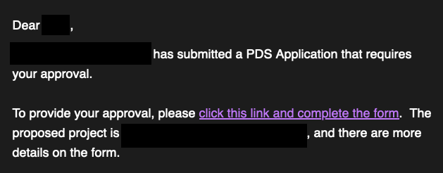

Clicking the link will lead to a form that asks the following questions:
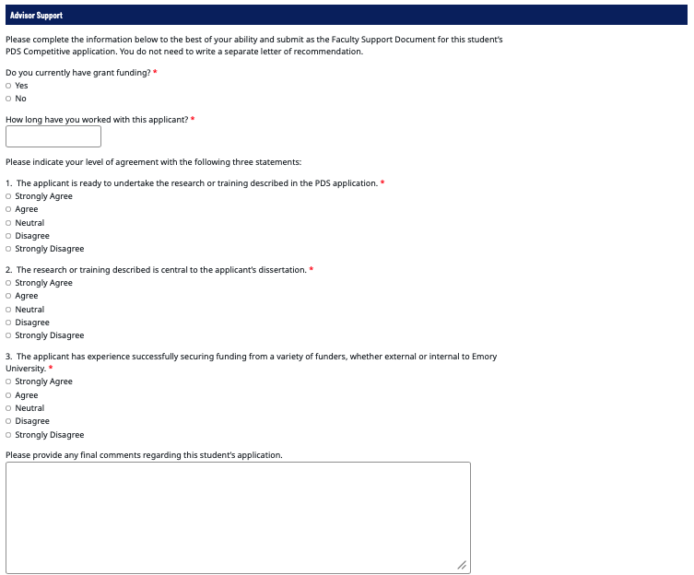

PDS Funding: Research
Research is an integral and necessary part of doctoral education. For example, students must travel to archives or research sites, they must administer surveys, or they must provide payment incentives for research participants. There is no limit on the number of times a student may receive PDS research funds, but the eligibility is dependent on the total amount of previously approved funds (both in the non-competitive and competitive categories). Once the student’s cumulative approved PDS funds (i.e., prior training funds received plus the current request) for support exceed the non-competitive eligibility total of $2,500, the student must apply for competitive funding.
Competitive applications are judged by a multi-disciplinary faculty committee. Funding is based on the training’s contribution toward the student’s progress, the student’s use of previous PDS funding, as well as efforts to find external support for the current proposal. The competitive process is highly competitive and only a select number of applications will be funded. Due to the total budget available, not all applications will be funded, and in some cases, students may receive partial funding for their application.
Successful competitive applications automatically subsume the remaining non-competitive lifetime eligibility in the research category. All applications for research support will be reviewed by the Laney Graduate School to be sure that the student is eligible and that the budget is not excessive.

A. Eligibility Requirements
- The applicant must be enrolled in an eligible Emory doctoral program at the time of the activity.
- The applicant must be in good standing at the time of the application, in the LGS as well as in their programs.
- The applicant may not have more than one incomplete at the time of application.
- The applicant must have submitted PDS Reports for all previous activities funded by PDS. This includes submitting a PDS Report to decline funding for previously approved applications. The exception to this policy is if the activity (conference, training, or research) has not yet been completed and the student may wait until the activity has concluded to submit the PDS Report and can still submit a new application.
- The applicant must meet any program requirements, when applicable.
- [Competitive applications]: The applicant for competitive PDS funding must also upload copies of PDS Reports for all previously funded training and research activity in their application. These PDS Reports will be considered by the review committee.

B. Support
PLEASE NOTE: An event is not eligible for PDS training or research funding just because it is called a “workshop,” “seminar,” or other similar terminology: if the session is focused on a narrow subject-matter, if it involves presentations of work-in-progress, if it operates like any general academic conference, or if there are attached workshops to a host conference, such events are not eligible for funding under the training or research category. In such cases, the student may apply under the PDS conference category only.
- Funds are intended to support travel and other direct expenses associated with accessing, acquiring and/or collecting data and/or scholarly resources not available at Emory. Included are domestic or international fieldwork, interviews, surveys, site visits, and archival research, to name just a few examples.
- Support may include reasonable living expenses for the duration of the research. Where the research takes place away from Emory and the student is not receiving stipend support, lodging expenses for the duration of the training may be eligible for PDS funding. If a student receives an LGS stipend during the period of research activity, support for lodging must be pro-rated by $25/night. More information is available in the PDS Expense and Budget Guidelines and FAQ sections regarding the “Amount of Stipend Applied” that is displayed in the online application.
- Students are expected to make full use of resources available at Emory before submitting PDS applications.
- Support is available for research activity that is essential to a student’s progress towards degree.
PLEASE NOTE: Paying for a (research) assistant is not eligible for PDS funding.
- If you have doubts about a particular event, please send an email to LGS.profdev@emory.edu with specific information about the event along with any website links, if available.

C. Review
There are four non-competitive Training/Research cycles and two competitive Training/Research cycles. Students will receive an approval or disapproval notice on the notification date listed for a given PDS cycle.
- Competitive review considers the amount of previous PDS research and training funding as well as the current progress of the student to PhD degree. The review committee expects that previous projects will put the student in a better position to complete the proposed project or training. In addition, the review committee expects the students to have made diligent and exhaustive efforts to find external funding sources. Only a select number of proposals are supported under the PDS competitive category.
- Successful proposals (these must address the prompts within the online Training/Research application form), both competitive and non-competitive, are clearly written for an interdisciplinary audience. Please explain the significance of your proposal without use of jargon or technicality. Make sure that your budget and project timeline are explicitly related; members of the committee should have no difficulty determining when different parts of the project will be carried out.
- Applications for funds intended to support significant components of dissertation research through this training, including preliminary research, are expected to document that the student has pursued, and is pursuing, external grant funding. This documentation will typically include cover letters or pages from grant applications that were awarded, denied, or are pending review. Favorable consideration will be given to student requests that demonstrate a persistent effort to identify and apply for external funding.

D. Funding Eligibility
For research the applicant has a lifetime eligibility of up to $2,500 (non-competitive), given certain conditions:
- There is no academic year limit according to (non)-candidacy. Students are eligible to apply for any amount at any time during the PhD program.
- Once a student has received $2,500 in non-competitive funding, they must apply for competitive funding.
- For certain amounts, the student must apply for competitive funding, even if part of the request may utilize non-competitive funding. For example: if a student is eligible for $1,000 in non-competitive funds and the application is for $2,000, they must still apply for competitive funding because the application exceeds the $2,500 non-competitive eligibility.
- These non-competitive limits are set. There are no exceptions to these limits.
- There is a $5,000 total eligibility for non-competitive and competitive training/research funds. Any amount beyond this, the student must apply for competitive funding (even if the student has not received $2,500 total of non-competitive training funds to-date). Please see the FAQ section for details.

E. Application Materials
- A complete proposal regarding the research you intend to pursue. This includes a signed and completed PDS Research or Training – Advisor Signature Form (do not use a previous year's version but download the current version from the PDS webpage).
- Documentation for all budget items, which in most cases, is printed from the web. This includes documentation for any line item you fill out on the application as it pertains to your training request. For more information, please see PDS Expense and Budget Guidelines section in this Handbook.
  - Failure to include documentation for any extra budget items will result in these expenses being removed from consideration for PDS funding. Convert all foreign costs to USD by inserting either a textbox or a table to display the conversion.
- Table summary of all expenses in USD.
- Any other internal program requirements must be met. These are dependent on your program. Please check with your PDS contact in your program for any clarification.

F. Pre-Planning
- Ensure that you have submitted completed PDS Report(s) for all previously approved applications.
- It is best practice to apply as soon as you know you will be attending the conference. Conference organizations plan for their conferences many years in advance, so you should have the information necessary to apply ahead of time.
- Do not incur any expenses in advance if you are unable to cover the full cost of the conference activity since in some cases, students will receive partial funding or no funding.
- Consult the section, How to Prepare Before Application Submission.

G. Application Submission
Please visit the section in this Handbook, How to Submit a PDS Application (LaneyConnect).

H. After Submission
Please visit the section in this Handbook, What To Do After Application Submission.

[IMPORTANT: For competitive training or research applications]:
Please upload the CV in the correct upload field. In the online application, you will be able to generate a link to your faculty member, who will need to fill out a brief form of support for your application (no letter of recommendation needed). This is due at the same time as your application for the given cycle. If an applicant does not have their faculty support submitted by the deadline, their application will not be eligible for review. The email link will be sent between 1-3 hours after your submission, so please plan accordingly and submit earlier than the final deadline.
Please note that there are two cycles for competitive applications, once in the fall semester, and once in the spring semester. If there are certain training or research activities that a student anticipates being accepted for after a given competitive cycle, we recommend they submit a preliminary application for the eligible cycle with as much information included as possible/available to them at the time of application. There will not be any review of new applications after the deadline has passed (e.g., if a student was accepted into a summer training activity in April, they should have applied with available details by the February competitive cycle). Students will not be considered for non-competitive funding if their competitive application is denied; these are separate processes and students should apply separately for non-competitive funding, if eligible.

The faculty advisor should receive an email that has the following format/link:

Clicking the link will lead to a form that asks the following questions:

How to Submit a PDS Application (LaneyConnect)

PDS applications and PDS Reports are submitted through LaneyConnect. Please visit the PDS website and click “Ready to apply” to access LaneyConnect: https://www.gs.emory.edu/professional-development/pds/apply.html.

Once you are logged into LaneyConnect, please click the PDS tab:

Expand the “Apply” ribbon:
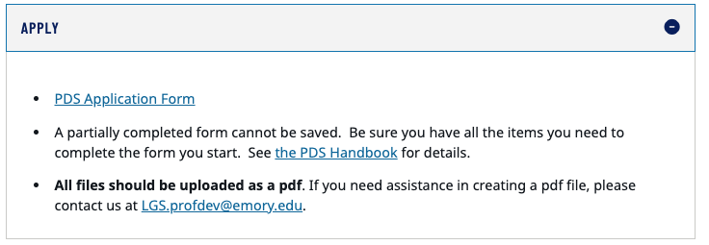

Click PDS Application Form to access the online application.
For competitive PDS training or research applications: Please note that the system takes between 1-3 hours to generate an email link to your faculty member so be sure to submit your application early enough so that the system generates the email link to them on time. All applications must be received by the deadline, including the faculty support submitted online. Incomplete applications will be removed from consideration for that competitive application cycle. This includes the faculty note of support that must be received within the system by the deadline.

We will provide below examples of the three types of application and make note of some important parts of the application process. The below examples do not go over every single field in the application, but points to certain parts that students may sometimes overlook in their application. Please ensure all documentations are in the proper orientation (not flipped sideways):
- Conference application
- Research application
- Training application
- Conference Application

Select Conference:
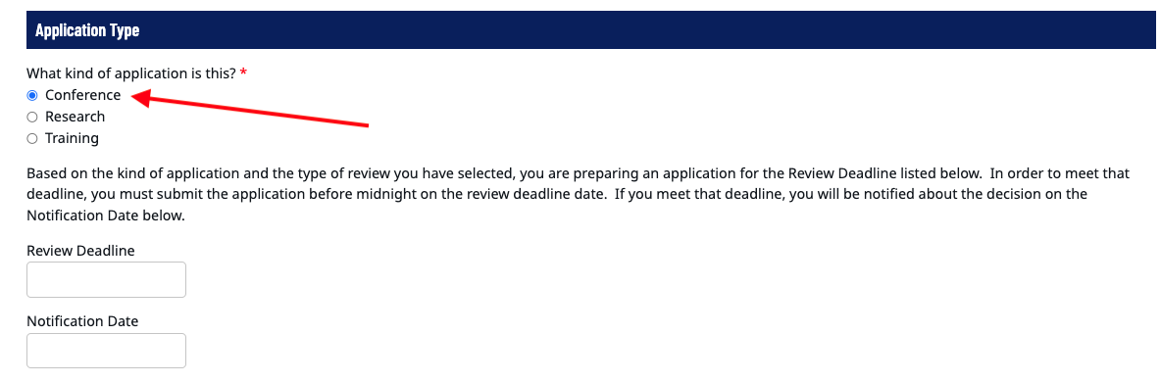
The Review Deadline and the Notification Date will be pre-populated: they indicate the deadline by which this application must be submitted and the date when you may expect to be notified. In general, students will not receive the approval or disapproval notice before this date.

(See below): If your application involves international travel, select “YES.” Please note that all international travelers are required to submit a separate International Travel Form which is available in LaneyConnect under LGS Forms (see the red box below). This separate form regarding the student’s international travel must be submitted and approved first before your PDS application may be reviewed/approved. Applications that involve international travel that are missing the International Travel Form approval will not be reviewed. It is the student’s responsibility to ensure that this separate form has been submitted and approved in a timely manner.
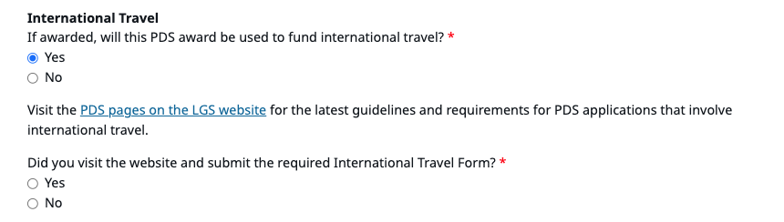

Enter and upload the required files. DO NOT upload the entire conference booklet under “Conference Information”:

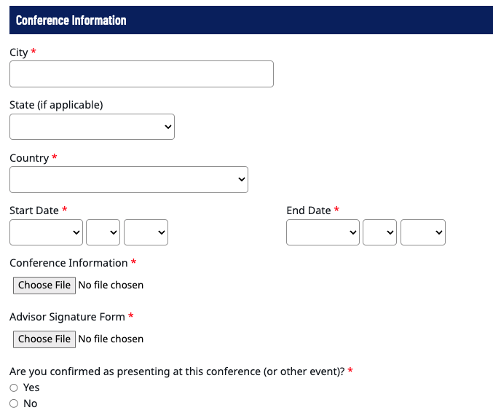
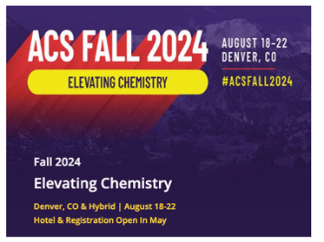
Conference Information (example from ACS website):
This 1-page shows:
- Conference name
- Dates
- Location

Advisor Signature Form (current file from PDS website):
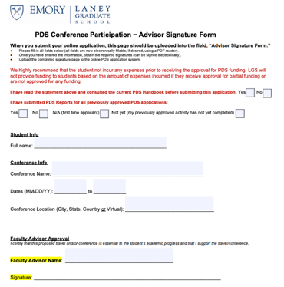
The form must be completed and signed by the advisor. Missing this form or missing the signature will result in a disapproval.

Under the Budget section, enter in the $ amount per expense and upload the documentation that corresponds to this $. If you enter in a $ value but the application is missing the proper documentation for that line item, it may be removed from consideration for PDS funding. We have provided some examples below:

FLIGHTS
For flights, we recommend using the Emory Travel. This is best practice since all flights funded by PDS must be purchased through Emory Travel. If it is your first time trying to book through Emory Travel CTM, please see the Travel section in the PDS Handbook. Use their portal to produce an estimate and screenshot this for your flight expense upload field (the dates and departure/arrival airports must be clearly displayed):

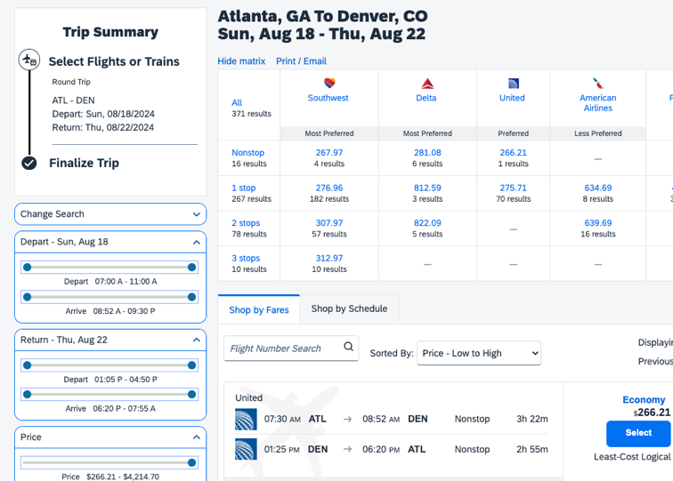

In the PDS application portal, the applicant will enter $267 and the above screenshot should be uploaded here:
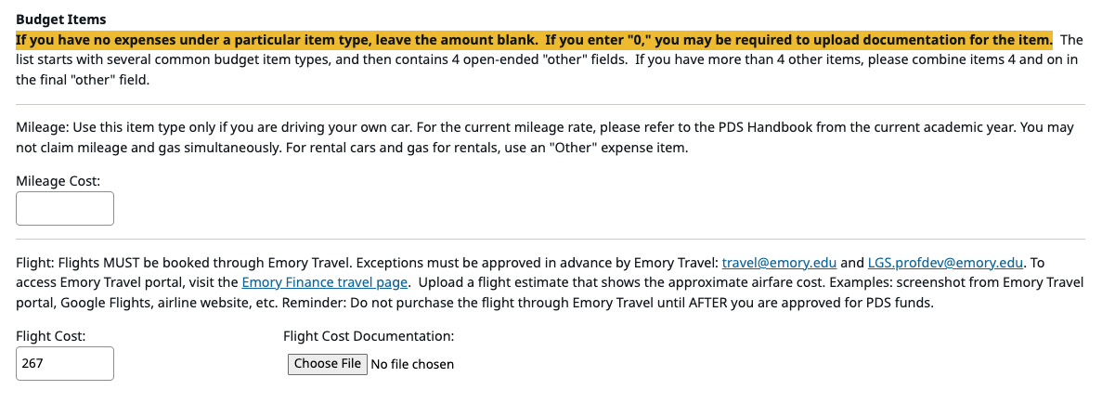
DO NOT upload multiple pages of estimates when only a single page of estimates will suffice.

LODGING
For lodging, the conference organizer will usually have their own rate, or the student may elect to produce a booking documentation through a hotel or AirBnB. For instance (following the same dates/location as above):

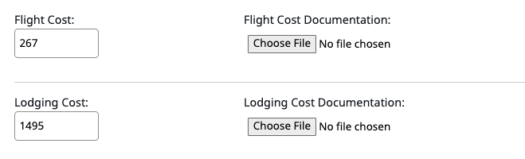

The Lodging Cost Documentation is displayed on the next page:

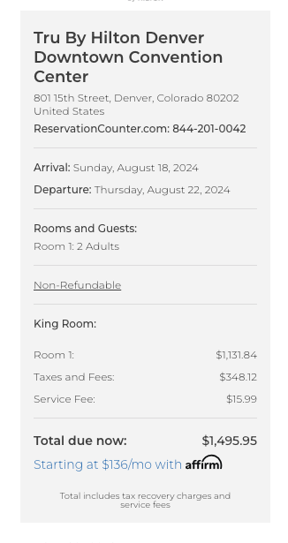
This is a screenshot taken directly from Hilton, that displays the location, the dates, and estimated total cost:

Similar to flight documentation: DO NOT upload several pages of lodging documentation. All that is required is a single booking that corresponds to the $ amount that you have entered.

REGISTRATION FEE
Visit the conference organizer’s website, take a screenshot of the registration cost, and if there are several fee schedules listed, please circle or box the exact fee that is relevant for your application. From the above example (ACS website):
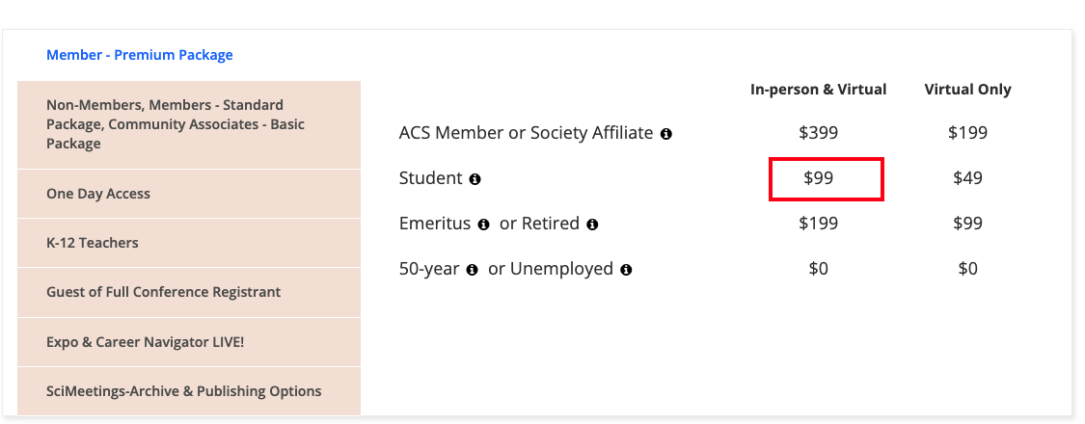

TOTAL AMOUNT REQUESTED
Once you have entered in the $ value for each item and the documentation corresponding to that expense, you will enter in the total amount requested for PDS funding. In the above example, the total amount would be $1,861 ($267 flight + $1,495 lodging + $99 registration).

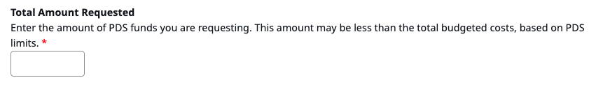

After you have entered in a value in “Total Amount Requested” you will be required to upload a Table Summary of all expenses, indicating the type of expense and the amount in $USD. Use Microsoft Word or Excel to create this table. It may be useful for you to retain this table summary since a final summary table will be required as an upload for your PDS Report after you have completed your conference/training/research. You will likely use this original table summary and add/amend it based on actual expenses for your final summary table in the PDS Report that you will submit after the conference/training/research has ended.

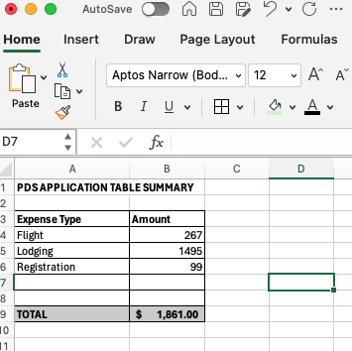

- Training Application

Select Training and select whether you are applying for the competitive or non-competitive cycle and enter your project information and the start/end dates:
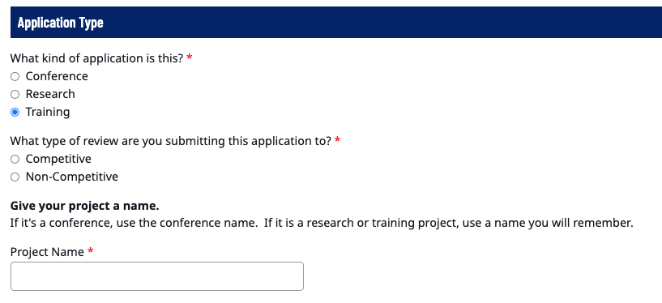

Enter the type of stipend you are receiving (if any):
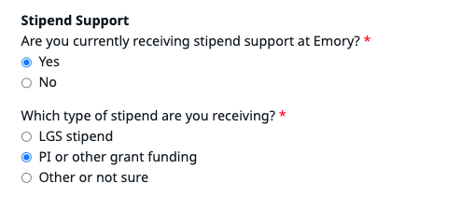
          - If two conditions are met: (1) you are currently receiving LGS stipend and (2) you are going to submit expenses for lodging, then you must prorate the lodging expense by $25/night in the line item, “Amount of Stipend Applied.” See the FAQ if you have further questions.
          - If you are on PI/grant funding or are not receiving LGS stipend, do not enter a value in the line item, “Amount of Stipend Applied.”

Enter in all other budget items just like you would normally with clear documentation of the $ amounts.

Important Information for Training Applications
- The training activity must show clear $ documentation.
- The training must be to support instruction essential for the student’s research progress to degree completion and not available at Emory. At this time, other professional development type trainings that are not strictly for degree progress are not eligible to be funded by PDS.
- For training/research: if the student is accessing archives or another institution’s resources or collaborating on research at another location, there should be official documentation from that location included in the student’s PDS application (they should amend it to one of the PDF file uploads).
- Any relevant documentation in a foreign language must be translated into English (attach the original with the translation, if needed).

After you have entered in a value in “Total Amount Requested” you will be required to upload a Table Summary of all expenses, indicating the type of expense and the amount in USD. Use Microsoft Word or Excel to create this document. It may be useful for you to retain this table summary since a final summary table will be required as an upload for your PDS Report after you have completed your conference/training/research. You will likely use this original table summary and add/amend it based on actual expenses for your final summary table in the PDS Report that you will submit after the conference/training/research has ended.

- Research Application

Select Research and select whether you are applying for the competitive or non-competitive cycle and enter your project information and the start/end dates:
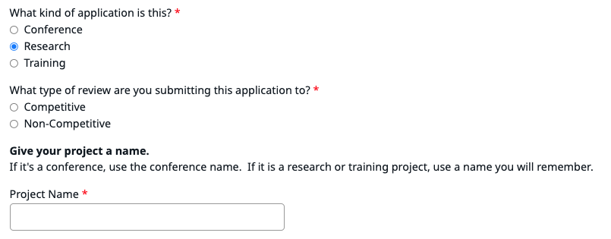

Enter the type of stipend you are receiving (if any):
          - If two conditions are met: (1) you are currently receiving LGS stipend and (2) you are going to submit expenses for lodging, then you must prorate the lodging expense by $25/night in the line item, “Amount of Stipend Applied.” See the FAQ if you have further questions.
          - If you are on PI/grant funding or are not receiving LGS stipend, do not enter a value in the line item, “Amount of Stipend Applied.”

Enter in all other budget items just like you would normally with clear documentation of the $ amounts.

Important Information for Research Applications
- If your research requires certification (IRB, IACUC, etc.), it must be included in the application. Or if it has not yet been approved, you must submit proof that it has been submitted to the certifying body for approval. BUT your application will not be approved until you send us the final approval letter to: LGS.profdev@emory.edu. In the email please indicate which cycle you are referring to so that we can correctly identify your application that needs to be reviewed.
- For training/research: if the student is accessing archives or another institution’s resources or collaborating on research at another location, there should be official documentation from that location included in the student’s PDS application (they should amend it to one of the PDF file uploads).
Any relevant documentation in a foreign language must be translated into English (attach the original with the translation, if needed).

After you have entered in a value in “Total Amount Requested” you will be required to upload a Table Summary of all expenses, indicating the type of expense and the amount in USD. Use Microsoft Word or Excel to create this document. It may be useful for you to retain this table summary since a final summary table will be required as an upload for your PDS Report after you have completed your conference/training/research. You will likely adapt this original table summary and add/amend it based on actual expenses for your final summary table in the PDS Report you will submit after the conference/training/research has ended.

How to Return Remaining PDS Funds

For all applications (including approved PDS funds that the student wants to decline), the student must submit the PDS Report through LaneyConnect.

Submitting PDS Reports with correct information ensures that historical records of all applications are accurate, and in the case of funds that the student declines, that these approved funds do not count against their lifetime eligibility.
  - If there is more than $50 remaining, the student must return the remaining funds with the proper form(s) and then submit the PDS Report.
  - If there is less than $50 remaining, it does not need to be returned, and the student’s application history should indicate the full amount received in the PDS Report.

If you received PDS funds that need to be returned, please proceed by following the steps exactly as outlined below (Please do NOT submit your PDS Report online until AFTER the steps below have been completed):
- Write a check made payable to “Emory University” with your Emory ID number clearly written in the notes section of your check. PLEASE NOTE: The check must be a personal check, money order, or cashier’s check. There is currently no electronic or online method to return unused funds.

- Complete the PDS Funds Return Form with your program administrator (PA). This form is available on the PDS webpage under “Forms and Application.” Please make sure all fields are completed.

- Print out the completed PDS Funds Return Form.

- Must Include the following in one envelope: (a) your check and (b) PDS Funds Return Form.

- Mail or Submit this envelope to: LGS Finance (PDS Funds Return), 1599 Clifton Rd. Floor 5, Atlanta GA 30322 (Google Map link to the building here).

  - PLEASE NOTE: If you are dropping off the envelope in-person and wish to speak to someone: please ensure that it is left with the receptionist at building entrance who understands this should be addressed to LGS Finance (let them know this is for PDS funds return that should go to an LGS Finance person).

- Complete the PDS Report through LaneyConnect: The student will indicate on the PDS Report how much of the actual funds were received and used. The student will submit this Report and their graduate program administrator (PA) will receive an email to certify the submission to complete the PDS Report process.

- Email LGS.profdev@emory.edu after you have completed steps #1-6 above to let us know that you have returned the remaining funds. We will confirm with LGS Finance that the funds have been received in good order and then we will close out the application’s PDS Report. Both the student and the PA will receive a final email closing out that specific PDS application and the status in LaneyConnect will change to “Complete.”

Students who were approved for funding in FY26, and who have any received funds remaining that they need to return must ensure that the funds are received and processed into Emory University’s bank account by November 15, 2026 for the Tax Office to have time to update the tax record for FY26.

Frequently Asked Questions (FAQ)

Q: How do I apply for PDS funds?
Students will apply for funding through LaneyConnect. Please visit the PDS website for the link.
PLEASE NOTE: Students with outstanding PDS Reports may not be eligible for future PDS funding until Reports for previously approved funds have been completed by the student and certified by the graduate program administrator. The only exception to this case is if the prior activity (conference, training, or research) has not yet concluded.

Q: What things should I consider before I apply?
Do not incur any costs in advance if you are not prepared to cover the full cost of the conference, training, or research activity in cases you receive no funding or only partial funding.
1. You must be in good standing with the LGS.
2. Please follow the funding guidelines discussed in the Budget Guidelines section of this Handbook.
3. You must have the support of your advisor and follow any program policies that govern PDS applications in your program.
4. Please use the funds for the stated intent. Failure to do so requires repayment back to Emory University.
5. Note the PDS Calendar with the deadline and notification dates for each cycle.
6. For all applications, aim to include a single summary table that clearly shows your total budget and requested PDS amount.
7. Ensure that you have submitted completed PDS Report(s) for all previously approved applications.
PLEASE NOTE: Please apply as early as possible. When applying to any other funding programs, they will not contact you for missing information or allow you to submit corrections past the deadline. Follow the same practice with PDS applications.

Q: What other requirements do I need to meet as I am applying?
Like other funding applications, it is imperative you follow the specific requirements to ensure your applications are complete and thorough. This includes all supporting documentation, signatures, and a proposal written for an interdisciplinary audience (for competitive and non-competitive research and training applications). In addition, being thorough also includes pre-planning for all types of PDS funded activity: training, research, and conferences. Please note the following:

1. Include any signatures that are required for your PDS application. Lack of signatures will result in an automatic denial of the PDS application.
2. Consult with the funding guidelines for each PDS application type available in the Budget Guidelines section of the PDS Handbook.
3. Supply complete documentation for each cost. The committees and the Laney Graduate School base decisions only on what is presented. We receive many applications during each cycle and time does not allow for the reviewer to infer costs.
4. In addition to #3 above, complete documentation means a full spectrum of costs associated with your application. Please calculate all costs correctly; due to the number of applications, time does not allow for the reviewer to calculate the expenses for each application. For example, providing a nightly room rate is incomplete; please include the nightly room rate multiplied by the number of nights you are staying, including all taxes associated. All foreign currency should include information about conversion rate to USD.
5. Please make sure all PDF scans are clear and legible and rotated to the correct alignment (not 90 degrees). An illegible scan may result in an application being denied.
6. The Laney Graduate School will not send reminders to students to supply different or new documents, or to obtain signatures after the application is submitted. If the application is incomplete, it will be denied. The student must wait until the next cycle if the activity remains eligible under the PDS policy.
7. Please adhere to your program’s own guidelines, and if applicable, the program’s own internal deadlines.
8. Documentation can take various forms. Please note in your application any pertinent information for each supporting documentation. Best practice may mean not including 20 pages of conference documentation. Instead, provide a one-page PDF of the conference coversheet that indicates your participation (when relevant), name of the conference, the dates, and the location. Please upload all documents in PDF format. It also means that if there are several different types of expenses, you should include a summary table of all expenses so that your total budget is clear.

Q: What is the $2,500 lifetime eligibility?
A: All students are eligible to be approved up to $2,500 each in PDS conference, training, or research funds.

Q: How can I see how much I have received to-date?
A: All students can check their PDS history by logging into LaneyConnect and scrolling down to the bottom of the PDS tab. It will display a record of all your applications to-date, as well as links to submit your PDS Reports (when applicable). If you see that the displayed application record is incorrect, please email LGS.profdev@emory.edu with details about your PDS application history and any relevant documentation. We will consult with relevant personnel and update the online system, if/when necessary.

Q: Are there candidacy limits (for training, research or conference applications)?
There are no candidacy limits. But students should consult the priority list before submitting their applications or incurring any expenses in advance (see the section, Preliminary Information).

Q: What is the $5,000 total eligibility for non-competitive and competitive research or training funds, the point at which students must always apply for competitive funding?
A: All students have a lifetime eligibility of $5,000 total of competitive and non-competitive training/research funds. All requests thereafter must be for competitive funding. See the examples below as reference:

Example #1: Student received $2,200 non-competitive training funds and $2,300 competitive research funds to-date (currently at $4,500 total combination of all forms of research and training funds).
Can this student apply for $1,000 non-competitive research funds? (The student has not been approved for any
non-competitive research funds to-date)
No. The approved competitive application automatically subsumes any remaining eligibility in non-competitive research funds.
Can this student apply for $500 non-competitive training funds?
No. This exceeds the $2,500 lifetime eligibility for non-competitive training funds, so the
student must apply for competitive funds. They may, however, apply for up to $300 in non-compet. training.
Can this student apply for $500 non-competitive research funds?
No. The approved competitive application automatically subsumes any remaining eligibility in non-competitive research funds.
Can this student apply for competitive training or research funds?
Yes. The student has been approved $4,500 to-date and is eligible to apply for up to $3,500 in competitive funding ($4,500 + $3,500 = $8,000 max). See the next question below for eligibility questions about the $8,000 lifetime eligibility.
Example #2: Student received $2,000 non-competitive training funds and $2,800 competitive training funds to-date (currently at $4,800 total combination of all forms of research and training funds).
Can this student apply for $500 non-competitive training funds? (The student has been approved $2,000 in non-competitive training funds to-date)
No. The approved competitive training application automatically subsumes any remaining eligibility in non-competitive training funds.
Can this student apply for non-competitive research funds and if so, how much? (The student has not been approved for any non-competitive research funds to-date)
Yes. The student is eligible to apply for up to $200 total in non-competitive research funds. This amount would result in the student having received $5,000 total in non-competitive and competitive training/research funding.

Q: What is the $8,000 lifetime eligibility for non-competitive and competitive training/research funds?
A: All students have a total lifetime eligibility of $8,000 of training and research funding in any combination of competitive or non-competitive funds. No exceptions will be made to this policy.

Example: Student received $2,400 non-competitive training funds and $3,800 competitive research funds to-date (currently at $6,200 total combination of all forms of research and training funds).
Can this student apply for $500 non-competitive research funds? (The student has not been approved for any non-competitive research funds to-date)
No. The approved competitive application automatically subsumes any remaining eligibility in non-competitive research funds.
Can this student apply for $100 non-competitive training funds? (The student has been approved $2,400 in non-competitive training funds to-date)
No. The student has already exceeded the $5,000 total of non-competitive and competitive funding. All applications after that point must be for competitive funding.
Can this student apply and be approved for $2,500 competitive training funds?
No. This exceeds the $8,000 total. The student is eligible for up to $1,800 in competitive training funds.

Q: [For training and research PDS applications only]: What is the section “Amount of Stipend Applied” that is found in the application portal?
If the student is receiving PI or other grant funding, the applicant may skip this section in the application portal.
A: Two conditions must be met for the student to enter an amount in this section in the application portal (by $25/night for lodging expenses): (1) the student is currently receiving a Laney Graduate School stipend and (2) the student is requesting PDS funding for lodging. Please subtract $25/nt from your lodging expense total. If the application does not include a request for lodging expenses to be covered by PDS, this section can be skipped in the application portal. If a student meets both conditions above, see the examples below to calculate this accurately:

Example #1: If the research or training requires lodging expenses for 10 nights in August which costs $1200 total, enter the following value in the line, “Amount of Stipend Applied”:
($25/night) * 10 nights = $250 applied
$1,200 - $250 = $950 lodging may be requested for PDS funding

Example #2: If the research or training requires lodging expenses for 25 nights from mid-May to June, which costs $2,300 total, enter the following value in the line, “Amount of Stiped Applied”:
($25/night) * 25 nights = $625 applied
$2,300 - $750 = $1,675 lodging may be requested for PDS funding

Example #3: The student is conducting research overseas and is requesting PDS research funding for $1800 roundtrip flight in August (15 days in between flights). Does the student have to apply their stipend to this PDS application? No. The student is only requesting flights (not lodging), so they are eligible to apply for full $1,800 expense in their PDS application.

Q: I submitted everything correctly, but my application is missing a signature. Will anyone contact me so that I can submit a new/complete signature?
A: No, this means you did not submit everything correctly. Given the number of applications received, we cannot track down each applicant’s signatures or incomplete documents. It is the student’s responsibility to submit a complete application. Please remember that this should be standard practice for applying to all funders. Other programs will not contact you for missing information or documentation. The student may apply again for the next cycle, if eligible.

Q: Can I apply for PDS Research or Training funding to attend a workshop?
A: An event is not eligible for PDS training or research funding just because it is called a “workshop” or a “seminar”: if the session involves presentations of work-in-progress, if it operates like any general academic conference, or if there are other attached workshops to a host conference, these are not eligible for funding under the training or research category. For such events, students may apply under the PDS Conference category only.
Q: I applied but was disapproved for a missing signature and incomplete documentation. Can I submit for the next cycle?
A: Yes, following the normal policies and eligibility criteria. The student may re-apply during the posted cycles (if eligible).

Q: I applied but was disapproved for missing PDS Report(s) for past approved applications. Can I submit for the next cycle?
A: Yes, following the normal policies and eligibility criteria.

Q: I applied but was disapproved for missing PDS Report(s) for past approved applications. But I submitted the PDS Report(s) already.
A: If this is the case, please check with your program administrator and make sure they followed the instructions regarding the PDS Report to make sure your past application record(s) have been updated correctly. Once that has been completed/confirmed, please contact us at LGS.profdev@emory.edu and we may generate a new approval notification email (provided all other aspects of your PDS application are in good order). A new approval, however, is not guaranteed for each cycle. It is always the applicant’s responsibility to make sure that their past applications have been updated/closed correctly. The student and PA will receive a final email notification that the application is now closed after they have completed the PDS Report process (disapproved applications are effectively closed and nothing further is needed).
The best way to ensure that all steps have been completed is to review your previously approved applications in LaneyConnect. The status for each should be marked “Complete.”

Q: I applied, but I realized I was missing some documentation, can I send an email with an updated application?
A: If the deadline did not pass for the current cycle, you may submit a new application with all the correct materials and that new application will be reviewed under its own merit (please indicate in this new application the correction so that the earlier application can be voided). If the deadline passed, you may apply during the next cycle, if eligible.

Q: I just found out I am attending a conference in August (or that I was accepted into a training program for August), and it is late June. Can I still apply? Is the PDS system closed in the summer?
A: See the PDS Calendar for the various cycles of PDS funding. After the final deadline has passed for the academic year, the application portal will not re-open until the next academic year (usually September).

Q: I missed the deadline because of _______, could I still be considered for the cycle that just closed?
A: No. You may apply during another PDS cycle (provided it remains in line with the PDS policy), if eligible.

Q: Will I receive the PDS funds before I complete my conference? What about PDS Training or Research funds?
A: Yes. All PDS funds may be disbursed to the student after the application has been approved. The student does not need to wait until the activity (Conference, Training, or Research) has completed to request the funds disbursement. After you have received the approval email for PDS funding, contact your program administrator (PA) or staff person responsible for processing PDS funds in your PhD program on how to receive the funds for the approved conference, training, or research application. We also recommend approved applicants consult the section, What To Do After Application Submission, in the PDS Handbook.
PLEASE NOTE: All funds are disbursed directly to the student. PDS will not pay labs, the student’s PI, or
any other advisor or staff member. If you have questions about the disbursement process/timeline, contact the designated staff person in your program (usually the PA). They can review the finance system to see where the application lies in the disbursement process.

Q: If I have funds left from a PDS approved application, can I use it to fund something else?
A: No. Approved PDS funds must adhere to the original budget and proposal, and they may not be used for other purposes. If you do need more funding, you may of course submit a new application for approval for the new budget and project in future PDS cycles, following the PDS policy.
If you have funds that need to be returned, please refer to the section above on returning funds.
Q: I received PDS funds in my bank account but did not spend the money. What must I do to ensure that these unused funds do not count against my lifetime eligibility?
A: Please see the question above regarding returning unused PDS funds.

Q: What if I did not receive the approved funds and I no longer need to use the approved PDS funds?
1. Complete the PDS Report online to decline the funds. Your graduate program administrator (PA) or designated staff person will certify this Report to complete the PDS Report process (and since you did not receive the approved funds, it will not count against your lifetime eligibility).
2. It is the applicant’s responsibility to ensure that their staff has correctly certified their PDS Report.

Q: Am I required to use Emory Travel for PDS-related trips?
A: Yes, if you will be using the approved PDS funds to purchase airfare. This is a University-wide policy, which PDS follows, for flight expenses. You may, at time of application, submit an estimate from any source (Google Flights, airline websites, etc.), but at the time of purchase, use Emory Travel (CTM or Sequel/Deem). Car rentals, trains, buses, or hotels do not need to be purchased through Emory Travel.
By booking your airfare through Emory’s approved travel agency partners, you are recognized as an Emory traveler which leverages Emory (through agencies and the airline carriers) with the ability to get you to safety during unforeseen circumstances.

Q: Can I purchase the flight through Emory Travel before applying?
A: We highly recommend students wait until approval before incurring any expenses, including airfare. Depending on the application, the student may be denied approval. Conference organizers plan conferences many years in advance, and therefore the student should have plenty of time to collect the necessary documents to apply for PDS as early as possible. Students may always upload an estimate rather than the ticket for the PDS application.
We recognize that flight prices fluctuate, so it may be in the best interests of the student to purchase flights in advance. Therefore, pre-purchased flights through Emory Travel may be eligible for PDS funding, with the implicit acknowledgment from the applicant that they have not yet been approved for any PDS funding. In such a case, please purchase the flight through Emory Travel.
PLEASE NOTE: Do NOT purchase flights or incur other expenses in advance if you are not prepared to cover the entire cost should you not receive any PDS funding.

Q: What if I found a substantially cheaper flight elsewhere or that CTM/Sequel is not showing me certain routes I found elsewhere?
A: Do not purchase the flight. Contact Emory Travel directly with a screenshot/information of what you have found with a comparison of the same itinerary with Emory Travel, if available at: travel@emory.edu. You should contact them with the exact itinerary from Emory Travel websites versus another webpage. It is not helpful for them for you to submit different flights or classes of travel that cost different amounts.
Emory Travel affords certain protections to the student and the University is able to maintain an accurate record of all students travelling in the case of an emergency, and therefore, there may be certain costs associated with purchasing through this system that are not just arbitrary.

Q: What document(s) do I need if the flight is upcoming, and it has not yet been purchased?
A: Prepare a PDF of flight estimate by one of the following methods:
- Use Emory Travel Portal, showing the approximate cost of travel.
- Use another comparable search engine (e.g., from airlines directly, Google Flights, Expedia, Orbitz, etc.), showing the approximate cost of travel.
Actual purchase of flights must be through Emory Travel if using PDS funds for airfare. If a cheaper flight was found elsewhere, please contact Emory Travel with screenshots of what you have found. They may be able to meet the lower price. Failure to use Emory Travel may mean that the flight expense request could be denied (other parts of the application may still be eligible for PDS). This is a University-wide policy for flight expenses.

Q: What document(s) do I need if I have already purchased the flight?
A: As noted above we highly discourage this practice of purchasing a flight prior to approval. But if you have already purchased a flight, prepare a PDF of the flight cost through the Emory Travel portal, showing your purchase through their system. This is the only accepted form of documentation for purchased flights. If a student uploads documentation of flight purchased outside of Emory Travel, it may be ineligible for funding through PDS.
PLEASE NOTE: Do not purchase flights or other expenses in advance if you are not prepared to cover the entire cost should you not receive any PDS funding.

Q: What if I have to stay extra days past the event date?
A: In the estimates, please show that your new date of travel is approximately the same as if you had traveled as soon as the event ended. For example, if your conference ends on 12/10 but you are flying on 12/16, you must submit documentation for (a) 12/10 and (b) 12/16 that show similar costs. If your later flight costs significantly more than the earlier flight, your request will only be funded up to the cheaper flight amount. If there is no documentation for both days, your PDS request for flights may not be eligible for funding.
PLEASE NOTE: PDS will fund flights and/or lodging up to 1 day before the first or 1 day after the last day of the conference or research/training without extra documentation. For example, if a conference ended on 12/10 and the flight is on 12/11, the application does not need to include two flight estimates. If an application includes longer stays without extra documentation, only the periods outlined above (up to 1 day before the first day of the conference and up to 1 day after the last day of the conference) will be funded.

Q: What if I need to fly back to Atlanta from a different city or if I need to fly to the event from a different city?
A: In the flight estimates, please show that your new departure (or arrival) city cost is approximately the same as if you had traveled to (or from) Atlanta. For example, if your conference is in New York, but you seek to be funded for a flight back from Boston (NYC-BOS will not be funded by PDS), you must submit documentation for (a) NYC-ATL and (b) BOS-ATL that show similar costs. If your new location costs significantly more than the return from the original city, you request will be funded only up to the amount from the event location. If you fail to provide documentation for both locations, your PDS request for flights will not be funded.

Q: What if I am attending different conferences and/or training/research activities in two cities consecutively?
A: You may submit two separate PDS applications (each with their respective forms included).
For example: If you have a conference in Los Angeles, then a conference in San Francisco, you will include the following flight documentation:
- PDS Application #1: Flights from ATL-LAX-SFO (please write a comment noting that the LAX-SFO flight is to the event found in Application #2)
- PDS Application #2: Flight from SFO-ATL
Each application will be considered on its own. Approval of one does not mean an automatic approval of one; and a denial of one does not mean an automatic denial of the other. Both applications should follow the PDS policy.

Q: What if I am splitting lodging with colleagues from Emory?
A: This is very common, and many students share costs for lodging with colleagues. You will indicate this information in the lodging section of the online application portal.
For your own records, at time of checkout, it may be beneficial for you to receive from the hotel (or AirBnB, etc.) a receipt that clearly shows your full name as an occupant.

Q: What if my expenses include costs in foreign currency?
A: If any included receipts show foreign currency, the table summary submitted must show all expenses converted to USD (include the current exchange rate at the time of application submission in the table). Any expenses with unconverted foreign currency may be removed from consideration for PDS funding. Any documentation in a foreign language must have the relevant portions translated to English.

Q: Can I get the LGS speedtype/smartkey to purchase my flight after approval?
A: No, we do not provide Speedtypes. LGS does not provide students with smartkey numbers. Please make sure to select your own personal payment method when purchasing flights through CTM or Sequel. If you are unable to use CTM, you must purchase through Sequel.

Q: Does PDS provide a system to pay a (research) assistant?
A: No, (research) assistants are not eligible for funding.

Q: Should I incur personal expenses first and then apply for PDS funds?
A: We highly discourage this practice. Just like any other funding program, an applicant should wait until the funds are approved before incurring any expenses. Students should wait until receiving the PDS application approval before spending the funds necessary to engage in the conference, training, or research activity. We do acknowledge, however, that for certain costs it may be in the best interests of the student to incur expenses in advance, and so such items remain eligible for PDS funding with the implicit acknowledgement from the applicant that they have not yet been approved for any PDS funding.
PLEASE NOTE: Do not incur any expenses in advance if you are not prepared to cover the entire cost should you not receive any PDS funding.

Q: Am I guaranteed PDS funds if I apply?
A: No. PDS funds are limited and applications that meet the eligibility criteria will be awarded based on the priority models submitted by each program. The funds are made possible through generation donations to LGS and while all PhD students are eligible to apply for the funds, they are not guaranteed the funds in all circumstances. Please note that no PDS funds belong to any individual’s student’s account or exist as a balance for any specific student. Each applicant is eligible to be approved up to the various lifetime limits for the PDS funding categories.
PLEASE NOTE: Do not incur any expenses in advance if you are unable to cover the full cost of the conference, training, or research activity in cases where you do not receive any PDS funding (or only receive partial funding).

Q: When will I receive a decision regarding the submitted PDS application?
A: Please refer to the PDS Calendar available in this Handbook (also displayed on the PDS website) for the notification dates of any given PDS cycle.

Q: I received an application disapproval because it stated that I have used all my funds for the academic year and/or the lifetime eligibility. But I did not use all the funds from previous applications that were approved, and I neglected to submit prior PDS Reports. Can the application be reconsidered?
A: It is the student’s responsibility to make sure that their application records are up to date by reviewing their application history on LaneyConnect and submitting the PDS Reports on time. Once the Report(s) have been submitted, your graduate program administrator should review your past application(s) to reflect the correct PDS funding amounts. Once that has been completed, you may contact our office at LGS.profdev@emory.edu for a second review of your current application. It is possible that your most recent application may receive an approval, but this is not guaranteed and subject to current budget.
PLEASE NOTE: Students with outstanding PDS Reports may not be eligible for future PDS funding until all Reports for previously approved funds have been submitted. The PDS Reports are also due for previously approved applications that the student wishes to decline. The Reports have a field to indicate they declined the funds.

Q: If I apply several cycles in advance for PDS funding but I will graduate before the conference, training, or research takes place, could I still be eligible for PDS funds?
A: No. If the student will graduate before the activity takes place, the student is not eligible to apply. PDS funds are reserved for graduate students, and if you will graduate during a specific term, any activity thereafter is no longer under the purview of the Laney Graduate School or the PDS program.

Q: If I am traveling internationally, where do I submit the International Travel Clearance Form?
A: There is a separate process (outside of the PDS application portal) for the International Travel Clearance (ITC) form which is available on LaneyConnect. Please ensure that your release form is submitted along with other required information and documentation through the International Travel Form process described on the PDS webpage. Once submitted, the process may take up to two weeks for final approval so please make sure to submit this separate Form as early as possible. Delays in your submission of the International Travel Form may result in delays in your current PDS application being reviewed. If the delay causes the timeline to pass the notification date of the current cycle, it does not mean that your PDS application was denied, only that there will be a delay until that International Travel Form has been given final approval (you will receive a separate email regarding this). Your approval of the International Travel Form is separate from the PDS approval process (approval of one does not mean the approval of the other). It is the student’s responsibility to submit the International Travel Form on time, we will not notify the student in advance that they are missing this form.
The International Travel Form is available in LaneyConnect under the tab, “LGS Forms.”
The student must have the ITC form approved before any PDS applications involving international travel will be approved.

Q: What if I spent more money than what was originally approved for PDS funding? May I request additional funds?
A: Yes, if the deadline has not passed yet, they may submit another application in the current cycle or apply in the next cycle (note that additional funding is not guaranteed, similar to all applications).

Q: BME PhD Students Eligibility
A: BME PhD students (Emory Labs only; if the student’s lab is located at GaTech, they are not eligible) have the same funding eligibility as all other PhD programs. Those who have already received PDS funds prior to this year will have those funds counted against their lifetime eligibility.

Q: Who is the DGS (Director of Graduate Study) or graduate program administrator (PA)?
A: Please visit the following webpage for the list of directors of graduate study for all PhD programs: https://gs.emory.edu/about/directors-staff.
PLEASE NOTE: Some PhD programs may have another staff member who is responsible for processing PDS funds and uploading PDS Reports. Contact your program administrator regarding this information.

Q: What if my faculty advisor is away or unavailable physically to sign the form?
A: In such cases, please obtain an email from them (with their name, email address, and date clearly displayed) indicating their support for your PDS Conference, Training, or Research activity. You may attach this behind your PDS Conference, Training, or Research signature form in lieu of the signatures on that first page. The faculty may also enter in an electronic signature into the form that you download online.

Q: If I have any questions about the PDS application process, should I email my DGS or the faculty advisor?
A: No. Unless it is about receiving their approval and signature(s) to travel to the specific conference or to engage in the specific training or research activity, we recommend you either contact your graduate program administrator (PA) or another staff member in your program familiar with the PDS application process. You may also contact us at LGS.profdev@emory.edu with questions regarding PDS.

Q: If I am considered a resident alien (i.e., I have been in the USA +5 years), what should I do to ensure that I am considered that status as described in the Tax Matters section?
A: If the student is a resident alien, then they would qualify under the first group indicated in the Tax Matters section. In order for the tax office to best address this, they would generally need to have documentation attached to the fund disbursement request that would show date entered in the USA, length of time in the USA, and a signed statement from the student indicating that they are a resident alien for tax purposes.
PLEASE NOTE: Regardless of classification, the PDS funds are taxable income to the recipient.

Q: If I submitted a PDS application but I no longer need the funds, what should I do?
A: Please email LGS.profdev@emory.edu with a request that your application be voided. We will void your application and it will no longer be on your application record.

Q: I still have more questions. Is there anyone available to walk me through the application process, if needed?
A: Yes. We would be happy to schedule a meeting with you to discuss any questions you may have about the PDS program or the application process. Please contact us at any time at LGS.profdev@emory.edu.

Tax Matters
Under Internal Revenue Service (“IRS”) regulations, all amounts received through the Emory Professional Development Support (“PDS”) program are generally considered taxable scholarship income to the recipients regardless of amount. In certain situations, taxes must be withheld when the funds are paid to the recipient as required by law. Tax forms (1099-MISC or 1042-S) will generally be issued to recipients in January of the year following payment.

The chart below provides general information on tax withholding and forms that apply for each situation. Note that these are general rules and there may be exceptions. Emory personnel are not able to provide specific tax advice and recommend consulting a tax advisor for specific income tax filing questions.

Tax Withholding & Reporting*
US Citizens, Green Card Holders, and Resident Aliens | Nonresident Individuals (F or J visa) | Nonresident Individuals (all other visa types)
No tax withholding required | Federal Tax withholding of 14% on every payment | Federal Tax withholding of 30% on every payment
Form 1099-MISC issued if total payments received from Emory (PDS as well as other funds) for the FY2026 are ≥ $2,000.  For FY2027 it is TBA. | Form 1042-S issued to all showing gross income and taxes withheld | Form 1042-S issued to all showing gross income and taxes withheld
*Regardless of the reporting threshold, all income is still taxable and must be reported on a tax return.

Some possible exceptions to taxability of income:
- Student is presenting at the conference or event. This applies to both resident and nonresident students. This must be noted on their PDS letter and Comment section in the Payment Request. Also attach Conference Program Agenda or Flyer showing student’s name
- Student’s home country - Nonresident student is eligible for a treaty exemption – Note that the Emory Tax Department will make this determination based on information in the FNIS system
- Nonresident student is performing work in another a foreign country outside the U.S (U.S. citizens, Green card holders, and Resident aliens are taxed on worldwide income)
- For resident student tax questions, please refer to these IRS resources:
  - 1099-MISC Information: https://www.irs.gov/pub/irs-pdf/f1099msc.pdf
  - 1040 Instructions: https://www.irs.gov/pub/irs-pdf/i1040gi.pdf
  - Tax Guide: https://www.irs.gov/pub/irs-pdf/p17.pdf

Further information on taxability, tax resources, definitions, etc. can be found on the Emory Finance Accounting website at: https://www.finance.emory.edu/home/accounting/tax/index.html
Information specifically for foreign individuals can be found here:
https://www.finance.emory.edu/home/accounting/tax/foreign/index.html

For international student tax questions, please contact nonresident.tax@emory.edu
For domestic student tax questions, please contact kathy.grant@emory.edu.

